Acoustic Levitator Proposal

Dalton Ludington, Daniel Opdahl

Experiment Description and Goals

An acoustic levitator is a device that uses sound waves to apply forces to an object that can suspend that object in the air. A standing wave is generated by arranging transducers in such a way that, when a certain frequency is played, standing waves are created [1]. We plan to construct an acoustic levitator using a 3D-printed apparatus with inlaid transducers controlled by an Arduino microcontroller. The specific weight of an object is defined as its weight on Earth per unit volume of material [2]. We propose using the acoustic levitator to investigate the question, “What is the largest specific weight of an object of set volume that can be levitated?” The calculation of the largest specific weight that can be levitated is essentially a question of how much acoustic force the apparatus can provide to counteract the gravitational force. Before conducting our experiments, we will determine the theoretical maximum amount of levitating force that the apparatus can provide. Then we will use that counter-gravitational force to calculate the largest specific weight that can be levitated by our device.

Motivation

We are very intrigued by acoustic levitation, and wish to explore the concept further. We have limited experience working with sound and acoustics. Through this project we hope to expand our knowledge of acoustics. The acoustic levitator will help our understanding how sound waves work. We expect to learn more about the properties of sound waves and how they interact with each other. We also hope to learn a great deal about standing waves. We expect to learn about properties of sound waves and standing waves because they are some of the fundamental concepts behind how the acoustic levitator works.

A second motivating factor that contributes to our desire to complete this project is to have the possibility to use the acoustic levitator for future Haunted Labs. We believe that the acoustic levitator we build will be a valuable educational tool for the children and adults who visit Haunted Lab. We currently have a few standing wave demonstrations that are already staples of Haunted Lab. The levitator will be a great addition to this section of the event.

Acoustic levitation is more versatile and cheaper than other forms of levitation, including magnetic, electrostatic, aerodynamic and optical levitation [1]. An advantage that acoustic levitation has over magnetic levitation is that magnetic levitation can only support ferromagnetic or diamagnetic materials [1]. Acoustic levitation is much easier to use than electrostatic levitation [1]. A downside to aerodynamic levitation is that it can alter or agitate the object being levitated, this does not occur with acoustic levitation [1]. Because of the benefits over other forms of levitation there are a variety of practical applications for acoustic levitation. There are many fields of study where the technology may be used. In biology, acoustic levitation may be used for the levitation of biological samples. Levitation of biological samples can be useful because levitation provides a contactless containment environment that removes factors like adhesion to container surfaces, which improves the accuracy of measurements [3]. Acoustic levitation can also be used in transportation for containerless holding during transportation. It can be used in the study of fluid dynamics and measurement of surface tension [1]. It has uses in chemistry for mass spectroscopy among other things. Acoustic levitation can also be used in the following fields: pharmaceutics, engineering, nano-assemblies, and many more [1]. We wish to further our understanding of a tool that can be versatile for many fields and applications. In finding the largest specific weight that the levitator can levitate, we will further our understanding of the capabilities of acoustic levitation.

Theory

A sound wave is a longitudinal wave that propagates throughout the air as variations in pressure. As a sound wave travels through the air, it creates areas of compression (high pressure) and rarefaction (low pressure). These areas of compression and rarefaction respectively correspond to the maximum and minimum displacements in the visual representations of sound waves, also called a waveform. As a sound wave travels through the air, the location of maximum and minimum displacement move with the wave. When a waveform is depicted, as in Figure 1, the sine wave represents a particle's displacement from its original position, *x* [4].

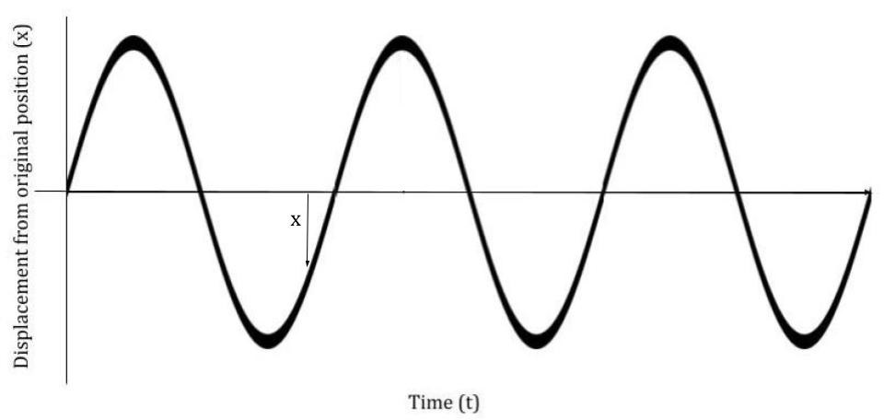

Figure 1: The displacement of a particle in the path of a sound wave at a particular position. As a sound wave travels through the air, particles will be displaced one way and then the other, oscillating back and forth as time goes on, though the individual particles have no net movement.

If two waves are in the same location, they are superimposed on one another, meaning that the displacements of both waves will combine [4]. Superposition of two waves can lead to anything from a complete cancellation of amplitude, as in Figure 2(A), to a doubling of amplitude, as in Figure 2(B), to creating more complicated waveforms.

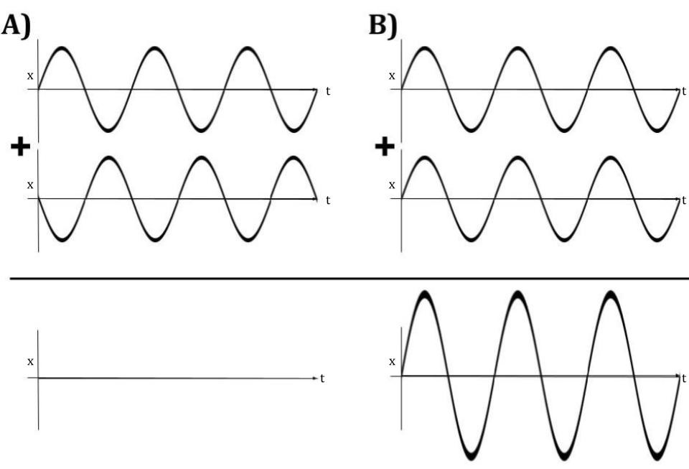

Figure 2: In both (A) and (B), waves are shown with displacement (x) on the vertical axis and time (t) on the horizontal axis. When two waves are superimposed on one another, the displacements of both waves will combine. Superposition of two waves can lead to anything from a complete cancellation of amplitude, as in (A), to a doubling of amplitude, as in (B).

Standing waves occur when two waves of the same frequency and amplitude that are moving in opposing directions combine. As shown in Figure 3, a standing wave will oscillate back and forth, sequentially going from wave 1 (maximum displacement) to wave 3 (minimum displacement) to wave 5 (maximum, displacement in the opposite direction) to wave 7 (minimum displacement again) back to wave 1. In a standing wave, the location of the peak displacement of the wave will not move through space. Also shown in Figure 3, standing waves have nodes, where the wave’s oscillation is at a minimum, and antinodes, where the wave’s oscillation is at a maximum. The nodes of standing waves are localized areas of low displacement and corresponding high pressure. The antinodes of a standing wave are locations of maximum oscillating displacement. This leads to antinodes having high pressure when the displacement is at a minimum, and low pressure when the displacement is at a maximum.

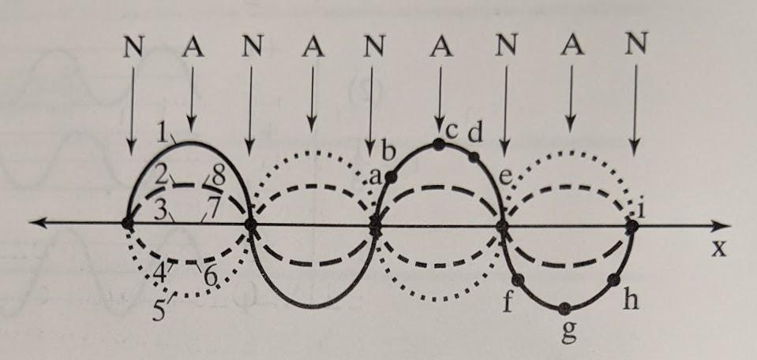

Figure 3: A standing wave oscillates, sequentially moving from position 1 to position 8. Antinodes (A) are the locations along the wave of maximum oscillation where the wave will oscillate from maximum displacement in one direction, to maximum displacement in the other direction, crossing the boundary of zero displacement each cycle. At the locations of the nodes (N), there is minimal oscillation. Image from Reference [5].

In our apparatus, transducers are arranged in opposing configurations, shown in Figure 4. The opposing configuration allows for each transducer on one side to pair up with a transducer on the opposite side and create a standing wave. If many pairs of opposing transistors are arranged in a crescent or bowl shape, the center nodes created by each standing wave are all superimposed on one another. This creates a focused central node, formed by the combination of all of the standing waves, as well as several nodes above and below the central node.

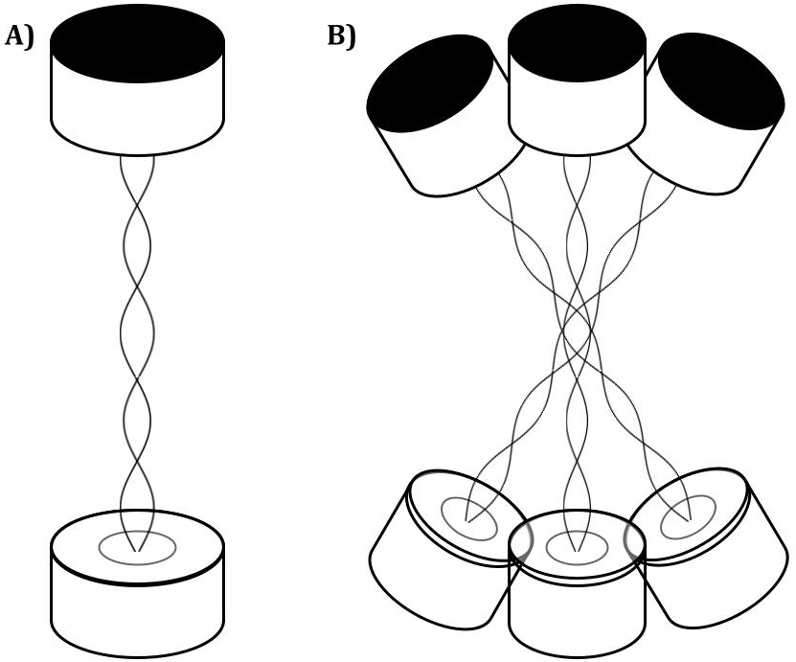

Figure 4: (A) Opposing transducers generate standing waves as their generated acoustic waves travel in opposite directions. (B) When many pairs of opposing transducers are arranged in a crescent or bowl shape, the center nodes created by each standing wave are all superimposed on one another. The arrangement of opposing transducers creates a focused central node, formed by the combination of all of the standing waves, as well as several nodes above and below the central node.

Figure 5 depicts the standing waves created by our apparatus. Opposing transistors arranged in bowl shapes create many standing waves that combine to create several nodes (dark bands in Figure 5 corresponding to small amplitudes) and antinodes (bright bands in Figure 5 corresponding to large amplitudes). Objects (green and purple spheres in Figure 5) can be levitated in the nodes of the standing waves.

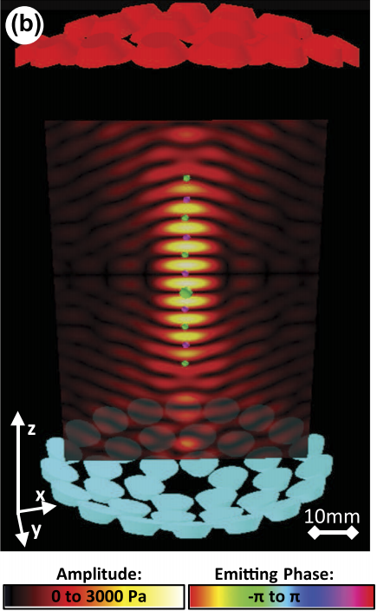

Figure 5: The standing waves created by the two opposing bowls of transducers in our apparatus combine to create many nodes (dark bands corresponding to small amplitudes) and antinodes (bright bands corresponding to large amplitudes). Objects (green and purple spheres) can be levitated in the nodes. Image from Reference [1].

In order to theoretically determine the largest specific weight of an object of set volume that can be levitated by our apparatus, we will primarily work with a model that relates air displacement to pressure, then relates pressure to force. Before we can determine the pressure created at the center of the apparatus, we will need to find the relationship between the voltage applied to the transducers and the pressure created at the nodes of the resulting standing waves.

For our purposes, we will be focusing on the central node because we will be levitating an object from that location. We propose a model that relates the air displacement at a node or antinode (caused by the summation of the standing waves generated by all of the pairs of transducers) to the local air pressure at that node or antinode. Using the relationship between the air displacement and the air pressure, we will calculate the average pressure achieved by the central node. Once we have calculated the pressure of the central node, we will find the force that the pressure is able to exert on an object being levitated using the relationship

. (1)

Multiplying our calculated pressure, , of the node by the cross-sectional area of the object we are levitating, , will yield the counter-gravitational force, , exerted on the levitated object. We show in Figure 6 that according to our model, our levitating object, a sphere of a given radius and specific weight, will be held in the central node, being held afloat by the high pressure surrounding it.

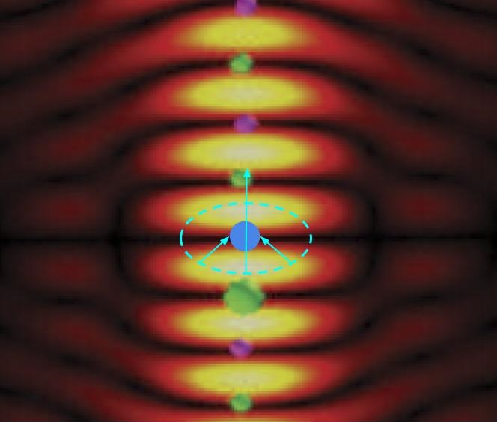

Figure 6: A close up of the central node of our apparatus. Our levitating object (dark blue sphere) is surrounded by an area of higher pressure (light blue oval) that exerts a counter-gravitational force on our levitating object. Image modified from Reference [1].

If our time and resources allow, we plan to expand our model to include levitation in other nodes above and below the central node. We expect as the nodes get farther away from the central nodes, they will have a smaller counter-gravitational force than nodes closer to the central node because the superposition of waves from pairs of transducers will align less.

Necessary Equipment currently owned by Luther [6]:

* Acoustically-transparent material to protect the transducers from falling objects. The acoustically transparent material can be something as simple as a thin piece of cloth.
* Small flat piece of wood approximately ¼in. x 8in. x 8in., for mounting the Arduino, power switch, and dual motor drive board.
* Soldering iron, tin and flux
* Hot glue gun
* Multimeter
* Cable peeler
* Miscellaneous hand tools
* Drill
* Oscilloscope

Necessary Equipment not owned by Luther [6]:

* TinyLev kit
  + 76 10mm 40 kHz transducers
  + L298N Dual motor drive board
  + 9V DC power adaptor
  + Arduino Nano
  + Wires
  + Power switch
  + 3D-printed TinyLev apparatus

Apparatus Construction [6]

The construction of the apparatus should be fairly straightforward with the purchased kit. First, we need to check the polarity of all of the transducers. The transducers are known for not having the terminals labeled correctly. We will do this using a multimeter to see if the output voltage is positive or negative [7]. We will then test the output of the transducers to make sure that they are functioning properly. We will select 72 transducers with the most similar decibel output. Once the transducers have been checked and selected, we then need to glue them into the base apparatus using hot glue. Next, as seen in Figure 7, we will wire the transducers together in six concentric circles, alternating positive and negative. Then, we solder the wires to the terminals of the transducers. We will then solder four longer wires to the wires connecting the terminals. These wires will run to the driver board. We will then check all of the wiring for shorts or bad connections using a multimeter. Next, we will set up the Arduino. We will program the Arduino using the provided C++ code and we are able to modify the code if needed [6]. We will then set up the control board by affixing the Arduino and the dual motor drive board to a small piece of wood. Then, we will wire our control board, connecting the dual motor drive board, Arduino, and variable power supply. Once this is done, using an oscilloscope, we will test the output function of the entire setup to ensure we are getting the desired function with the correct voltage levels. Next, we test all of the connections from the control board to the base apparatus using a multimeter. When this is finished, we need to check the output to each of the transducers using an oscilloscope to make sure that each transducer is receiving the correct input signal. We can then finish by gluing the legs to the apparatus base. When this is done, we can test the system by trying to levitate small objects.

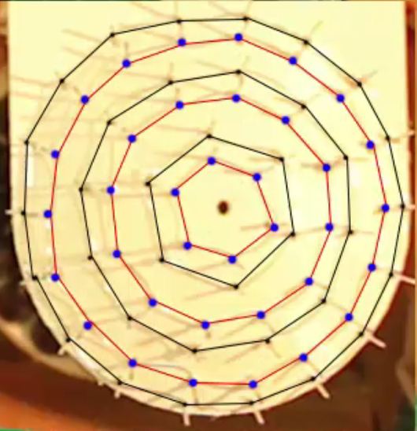

Figure 7: A picture of the top of the TinyLev apparatus after the transducers have been installed and the transducers have been wired together. The red wires are positive and black wires are negative. The six concentric circles formed by the wires can be seen clearly. Image from Reference [6].

Potential Difficulties

There are some potential difficulties that we expect. It is noted that the positive and negative terminals labeled on the transducers are often wrong [8]. Knowing this, we will go through each transducer and test its polarity with a multimeter by checking whether the output voltage from the transducer is positive or negative [7]. Checking polarity is easy to do, but it is time consuming and will have to be done carefully to ensure that we mark the terminals correctly.

We also need to test the sound intensity created by the transducers. We believe that we can measure the decibel output using a decibel meter, then relate that to the air displacement and pressure. For the best results, it would be ideal to have transducers that put out approximately the same pressure waves, but it is not necessary.

Additionally, soldering our transducers to the circuit will present challenges for us. Neither of us have soldered much before, so we will have to practice our soldering skills in advance before we do any soldering on the actual apparatus. When we do work on our final apparatus, we will have to be mindful to not lay down too much solder that we form electronic connections where we do not mean to. We will also have to be careful to not leave our soldering iron on the connection points for too long, or we may damage the electrical components which could cause them to improperly function.

Another potential difficulty is figuring out how to analyze the system. We are not yet certain what generalizations we can reasonably make about our apparatus. Can we model each bowl of the apparatus as a single emitter of an acoustic wave, or will we need to account for each individual transducer? How might we account for opposing transducers that output significantly different pressures? If the force delivered by our sound waves is not consistent over a couple of seconds, how will we account for that when determining the force?

Summary

Through this experiment, we aim to determine the largest specific weight of an object that the acoustic levitator can levitate. Finding the largest specific weight that can be levitated will involve investigating both the theoretical and experimental maximum amount of force that sound waves can deliver onto a particle being levitated. Our apparatus is designed to create many standing acoustic waves between many pairs of opposing transducers arranged in two bowl shapes. The opposing arrangement allows the nodes and antinodes of the many standing waves to align and create a strong central node in the middle of the region between the two bowls. We believe that we can theoretically determine the levitating force delivered to the particle by relating the air displacement to the pressure, then relating the pressure to the levitation force. We plan on measuring the air displacement by measuring the decibels of the system using a decibel meter, then relating the decibel output to the air displacement.

We are interested in conducting this experiment because we would like to better our understanding of acoustic levitation and the properties of waves in general. We would also like to construct the levitator for possible use in future Haunted Labs.

Many of our anticipated difficulties are engineering related, which might occur during the construction of the apparatus. We anticipate difficulty in calibrating the transducers, as well as soldering all the necessary connections, since these are new skills for us. Additionally, we think that we may run into difficulty analyzing the system theoretically. We need to find a way to relate the air displacement of a sound wave to the levitation force created by that sound wave.

References:

[1] *TinyLev: A multi-emitter single-axis acoustic levitator.* Asier Marzo, Adrian Barnes, Bruce W. Drinkwater. AIP Publishing. August 10, 2017. <https://aip.scitation.org/doi/pdf/10.1063/1.4989995>

[2] *Engineering Mechanics Statics.* Michael E. Plesha, Gary L. Gray, Francesco Costanzo. McGraw-Hill. 2013.

[3] *Raman acoustic levitation spectroscopy of red blood cells and Plasmodium falciparum trophozoites.* L. Puskar, R. Tuckermann, T. Frosch, J. Popp, V. Ly, D. McNaughton, B.R. Wood. Lab Chip 7(9), 1125–1131. August 3, 2007. <https://pubs.rsc.org/en/content/articlelanding/2007/LC/b706997a#!divAbstract>

[4] *Modern Physics, 5th Edition*. P. A. Tipler and R. A. Llewellyn, W. H. Freeman and Company, New York, 2007.

[5] *The Physics of Sound.* Richard E. Berg, David G. Stork. Pearson Education. 2005.

[6] *Acoustic Levitator.* UpnaLab. Instructables. August 14, 2017. <https://www.instructables.com/Acoustic-Levitator/>

[7] *Tutorial: Marking the Polarity of Ultrasonic Piezos using a Multimeter.* UpnaLab. June 17, 2019. <https://www.youtube.com/watch?v=0HaKv3aJQWA&feature=emb_logo>

[8] *I Built an Acoustic LEVITATOR! Making Liquid Float on Air.* Dianna Cowern. Physics Girl PBS Digital Studios. December 13, 2017. <https://youtu.be/ABjRnSYw-4k>